UPPWISE INDIA

www.uppwise.com



**Quaterly Development Planning**

**Q1-2024**

**Feature: Document Checklist Management**

**Feature Title:**

Document Checklist Management

**Priority:**

Critical

**Submitted By:**

SPM

**Feature Description:**

This document is targeted to propose the solution for Document Management requirement.

**Target Users:**

Project Manager, Admin Users, Collaboration Users

**Acceptance Criteria:**

**Form Builder Configuration:**

Start by navigating to the company settings. Once in the company settings, open the form builder. In the form builder, specifically select the initiative form you are working with. Look for the menu icon and click on it to reveal additional options. Within the menu options, locate and click on the configuration settings.A tab named "Checklist Management" will be visible. Click on this tab to access further settings.

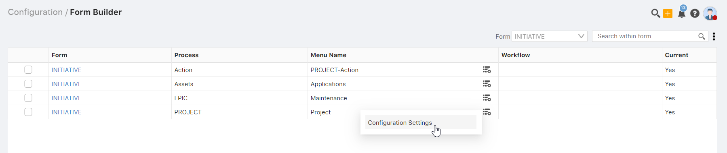

Inside the Checklist Management section, you will find a switcher. Enable this switcher to activate the document management feature in the application. Once the switcher is enabled, a dropdown menu will appear. This dropdown allows you to choose the document process that aligns with your requirements.

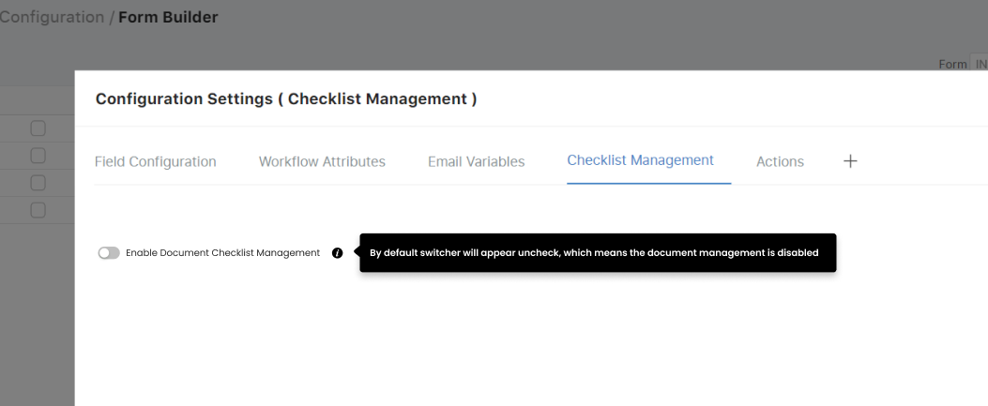

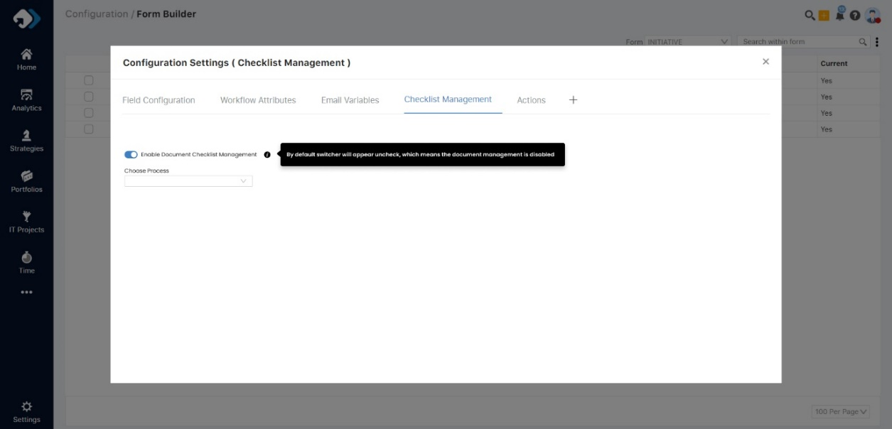

Checklist creation in Initiative Workflow:

**Tab Addition:**

* A new tab named "Checklist Creation" will be added to the workflow configuration within the initiative.

**Object Creation Conditions:**

* Users can define trigger conditions for automatic object creation.
* Fields for defining conditions include Workflow Attributes (attributes from form configuration), Condition (operator), and Value.

**Action Link:**

* Link is provided under the object control to open a popup for defining actions related to the conditions.
* When user will fill the fileds based on condition then need to save it, and after link gets visible for the access.

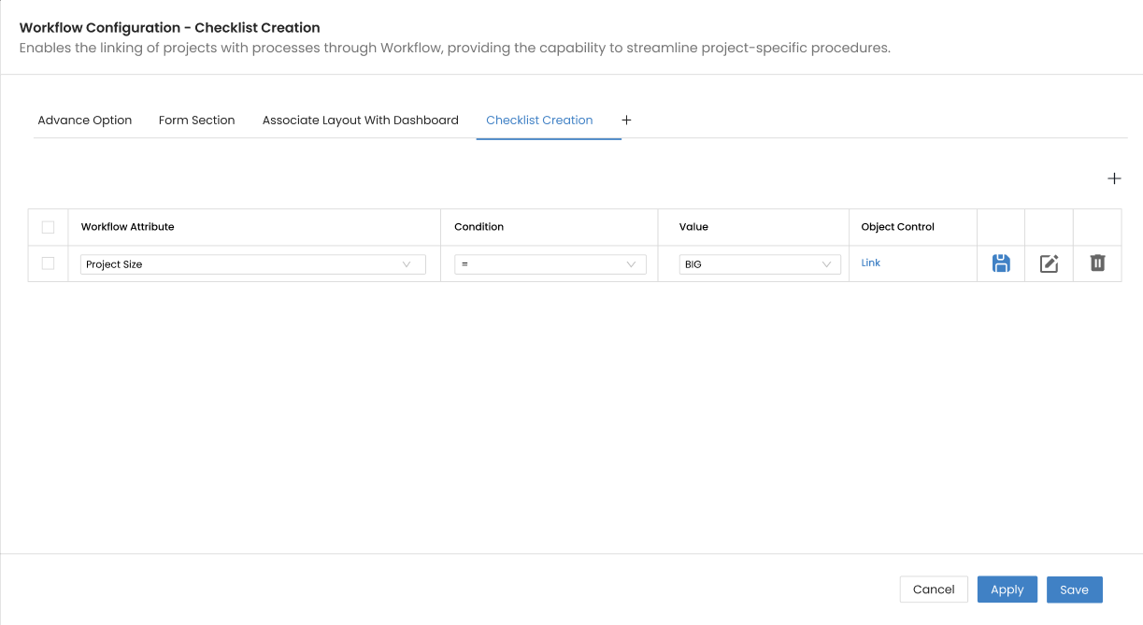

**View Object Control Popup:**

* Clicking on the link opens a popup containing a grid for adding multiple entries.
  + **Title:** This field is basically title which user wants to add.
  + **Weight:** A mandatory numeric field. (Value should not be greater than 100 & there will be no negative value can come)
  + **Mandatory:** A mandatory column provide to set the action important via switcher.
  + **DFS:** This field will load the DFS structure if created and will be **optional to select.**
  + **Default:** Enable switcher will come based on the user preference whether they want to add or make it default.

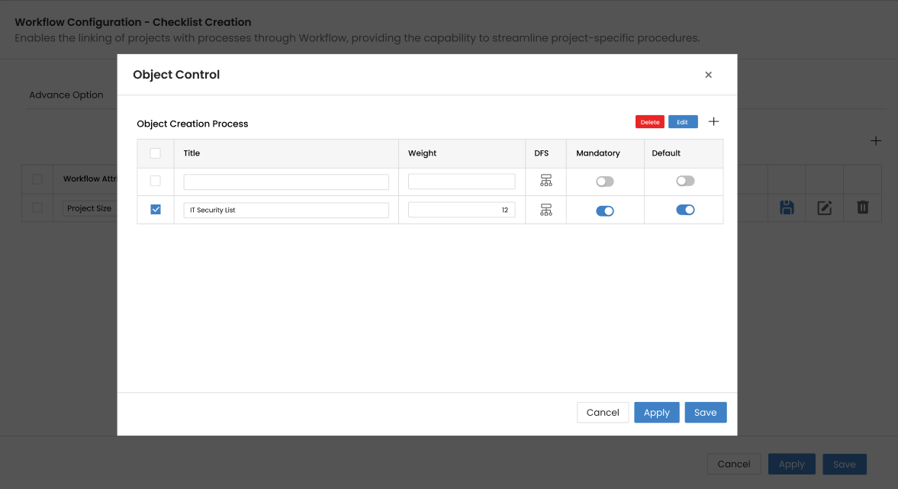

**Object Creation Process:**

* If more than one condition is defined, only one condition will be executed at a time.
* When a condition becomes true for the initiative, the defined objects in the Action popup will be created automatically.
* The new objects will be created according to the current workflow defined for the respective process.
* If the condition changes, we will prompt the user and inform them that the condition has been updated. Existing documents associated with the previous condition will be removed but not the unmatched one.

**Over Analytic Dashboard:** All these custom fields which are required are coming under the data source because the scripts are created currently base on AXA, In future if there will be any custom field get add then need to add the query and load it and only for document type teamspace register table.

This feature streamlines the process of initiating predefined actions based on specific conditions within the initiative workflow.

**Threshold Setting**

In the company settings page, a new setting will be introduced specifically for threshold settings concerning document status. This setting will play a role in computing the KPIs for document management.

However, it will only be visible and accessible when the process is enable over the form.

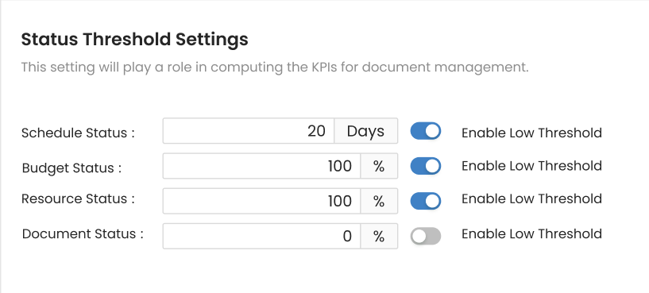

We can plan to display the document status threshold settings on the status report, a feature that was previously available in the health widget. The color indicators for different values will be integrated into the **project health data source** (In Analytics).

image

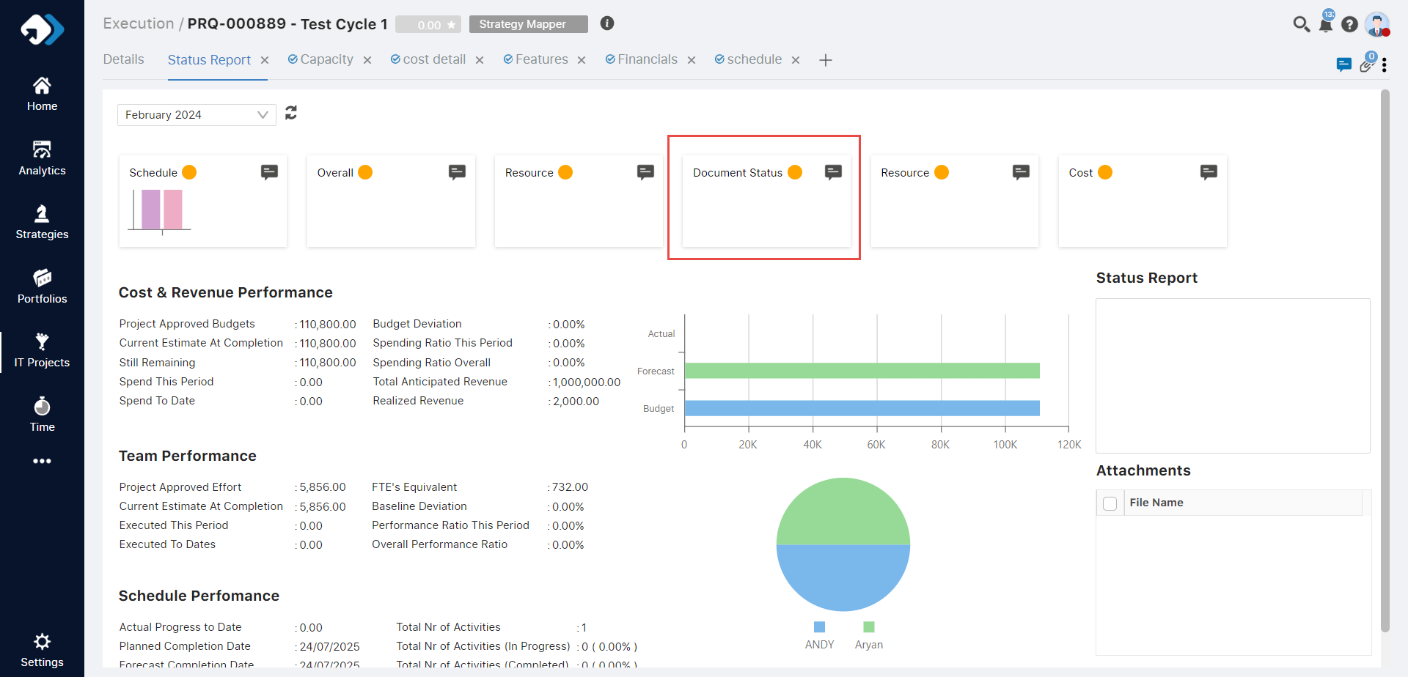

**Reporting Key Library**

There will be a new key “Document Compliance Index” will be added in **Standard Codes > Initiative Management > Reporting Key Library**, that will be calculated based on the formula provided.

It will enable if Document checklist enable on initiative form configuration.

Key will appear in multiple places in the application like portfolio.

**Weight and the Status** field will be used to calculate the KPI color based on the formula provided in below table.

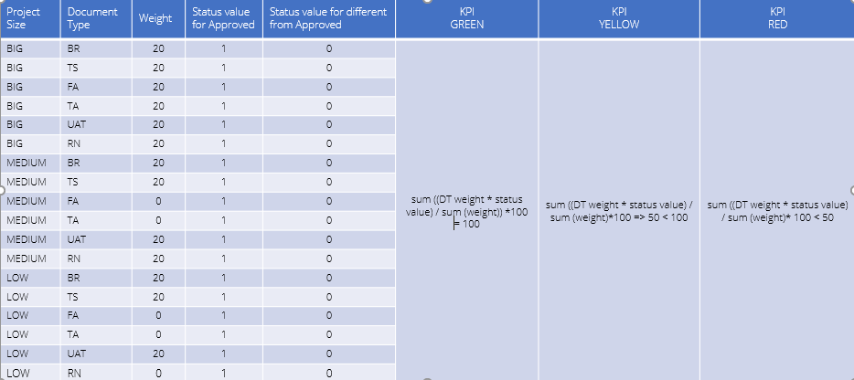

**Key appear over portfolio**

Need to add one column named as document over the project status update on portfolio which will show the key data over the same (similar functionality like POX)

**How functionality works in POX:**

**Reporting Key Library - Standard Code Arrangement**

The Reporting Key Library includes the arrangement of keys based on standard codes. Users have the option to define the sequence by choosing the order and status of keys. Here Each key can be marked as either active or non-active, with some being standard and others customizable.

These designations reflect on the Health Widget and influence project status updates.

**Project > Project Status - Project Health Widget:**

* If the key is marked as active in the standard code, users can modify the project status.
* If the key is non-active, no changes can be made.

**Portfolio - Project Status Update:**

* Projects are loaded here with status updates aligned with the Health Widget and color indicate the value based on formulas.

**Reference screenshot below:**

